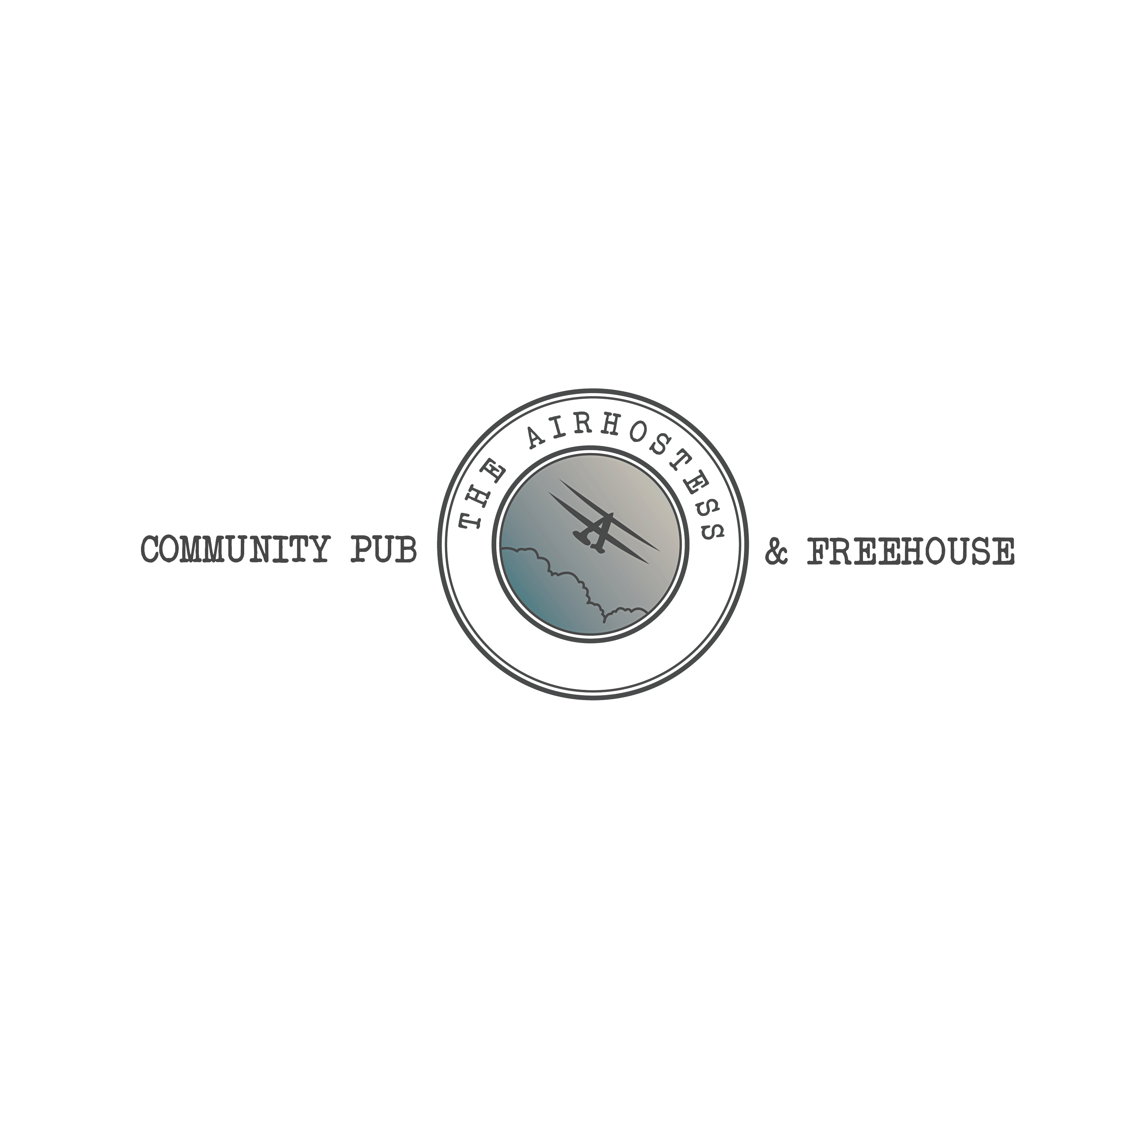

- DESSERT MENU –
Desserts
Cherry Bakewell Crumble Tart with Custard (v, df*) £6.50
Custard Panna Cotta with forced Rhubarb and a Honey and Ginger Crumb (gf) £6.50
Salted Caramel and Chocolate Tart with Chocolate Soil
and Clotted Cream Ice Cream (nf, v) £7.50
Sticky Toffee Pudding with Custard or Vanilla Ice Cream (nf, v) £7.50
Chocolate and Cinnamon Knot with Pistachio and Vanilla Ice Cream (vg, df) £7.50
Cheeseboard - With Colston Basset Stilton, Brie de Meux, Caramelised Onion Cheddar,
Bank Farm Vintage Cheddar, Sourdough Crackers, Grapes
and Red Onion Chutney (v, nf) £10.50
Purbeck Dorset Ice Creams (v, gf*)
Vanilla
Strawberry
Swiss Chocolate
‘Scoop of the Day’
1 Scoop - £3.50. 2 Scoops - £5.00 3 Scoops - £6.50

(gf) gluten free (df) dairy free (nf) nut free (v) veggie (vg) Vegan *available on request
Please let a member of staff know if you have and food allergies or intolerances. All items subject to availability.
The Air Hostess, Stanstead Avenue, Tollerton, Nottingham, NG12 4EA
t: 0115 648 0439 f: @theairhostesstollerton e: info@theairhostesstollerton.co.uk w: www.theairhostess.com

